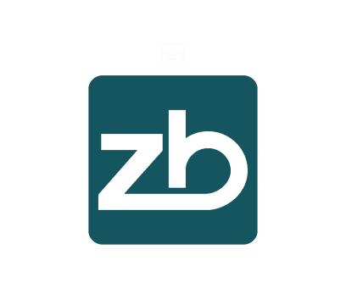
APPLICATION FORM
DOCUMENTARY LETTER OF CREDIT

TYPE: | [ ] SIGHT [ ] USANCE/DEFERRED: ____ DAYS FROM _____
APPLICANT | NAME:
APPLICANT | ADDRESS:
APPLICANT | CONTACT NO.:
APPLICANT | EMAIL:
APPLICANT | CONTACT PERSON:
AMOUNT OF LC:
BENEFICIARY BANK | BANK NAME:
BENEFICIARY BANK | BANK ADDRESS:
BENEFICIARY BANK | BANK SWIFT CODE:
BENEFICIARY BANK | BANK ACCOUNT NO.:
BENEFICIARY (RECEIVER/  ACCOUNTHOLDER IN BENEFICIARY BANK) | NAME:
BENEFICIARY (RECEIVER/  ACCOUNTHOLDER IN BENEFICIARY BANK) | ADDRESS:
BENEFICIARY (RECEIVER/  ACCOUNTHOLDER IN BENEFICIARY BANK) | PHONE:
BENEFICIARY (RECEIVER/  ACCOUNTHOLDER IN BENEFICIARY BANK) | EMAIL:
VALIDITY/EXPIRATION DATE: | 90 DAYS VALIDITY
SHIPMENT DETAILS: | LATEST SHIPMENT DATE: | 15 DAYS BEFORE EXPIRY
SHIPMENT DETAILS: | SHIPMENT FROM:
SHIPMENT DETAILS: | SHIPMENT TO:
INCOTERM: | CIF / CFR / FOB
PARTIAL SHIPMENT: | ALLOWED / NOT ALLOWED
TRANS-SHIPMENT: | ALLOWED / NOT ALLOWED
PROFORMA INVOICE/CONTRACT DETAILS: | MERCHANDIZE DESCRIPTION:
PROFORMA INVOICE/CONTRACT DETAILS: | PROFORMA INVOICE REF.:
PROFORMA INVOICE/CONTRACT DETAILS: | PROFORMA INVOICE DATE:
REQUIRED DOCUMENTS
TRANSFERABLE: | YES / NO:
INSTRUMENT SENT VIA: | SWIFT:
INSTRUMENT SENT VIA: | COURIER:  BENEFICIARY  CONTACT PERSON:
INSTRUMENT SENT VIA: | FULL ADRESS:
INSTRUMENT SENT VIA: | PHONE:
INSTRUMENT SENT VIA: | EMAIL:

